Interactive Methodology Explorer Link [Here]

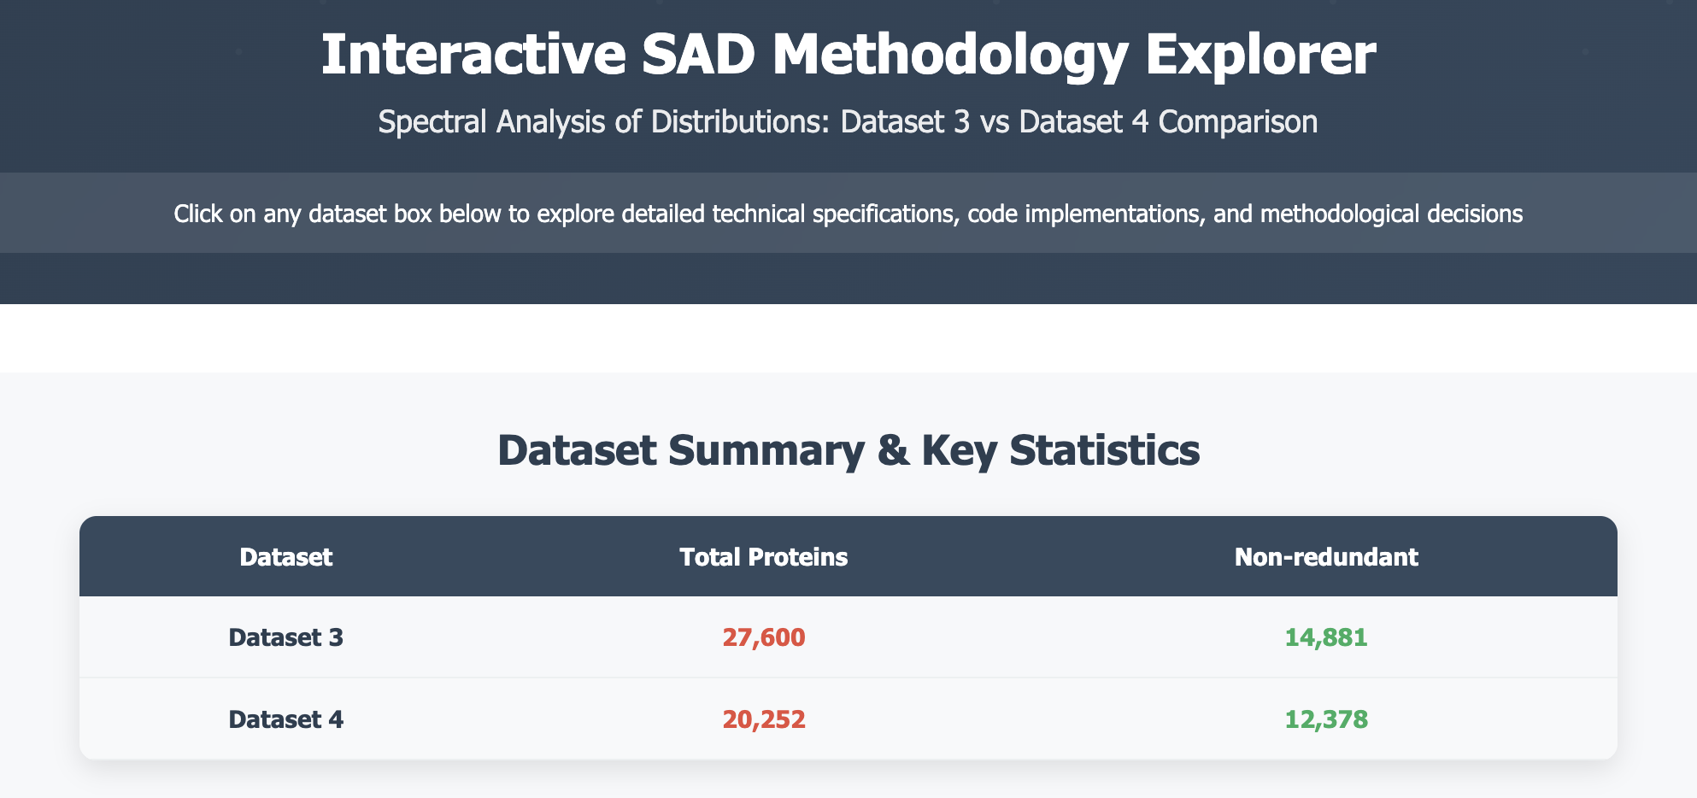
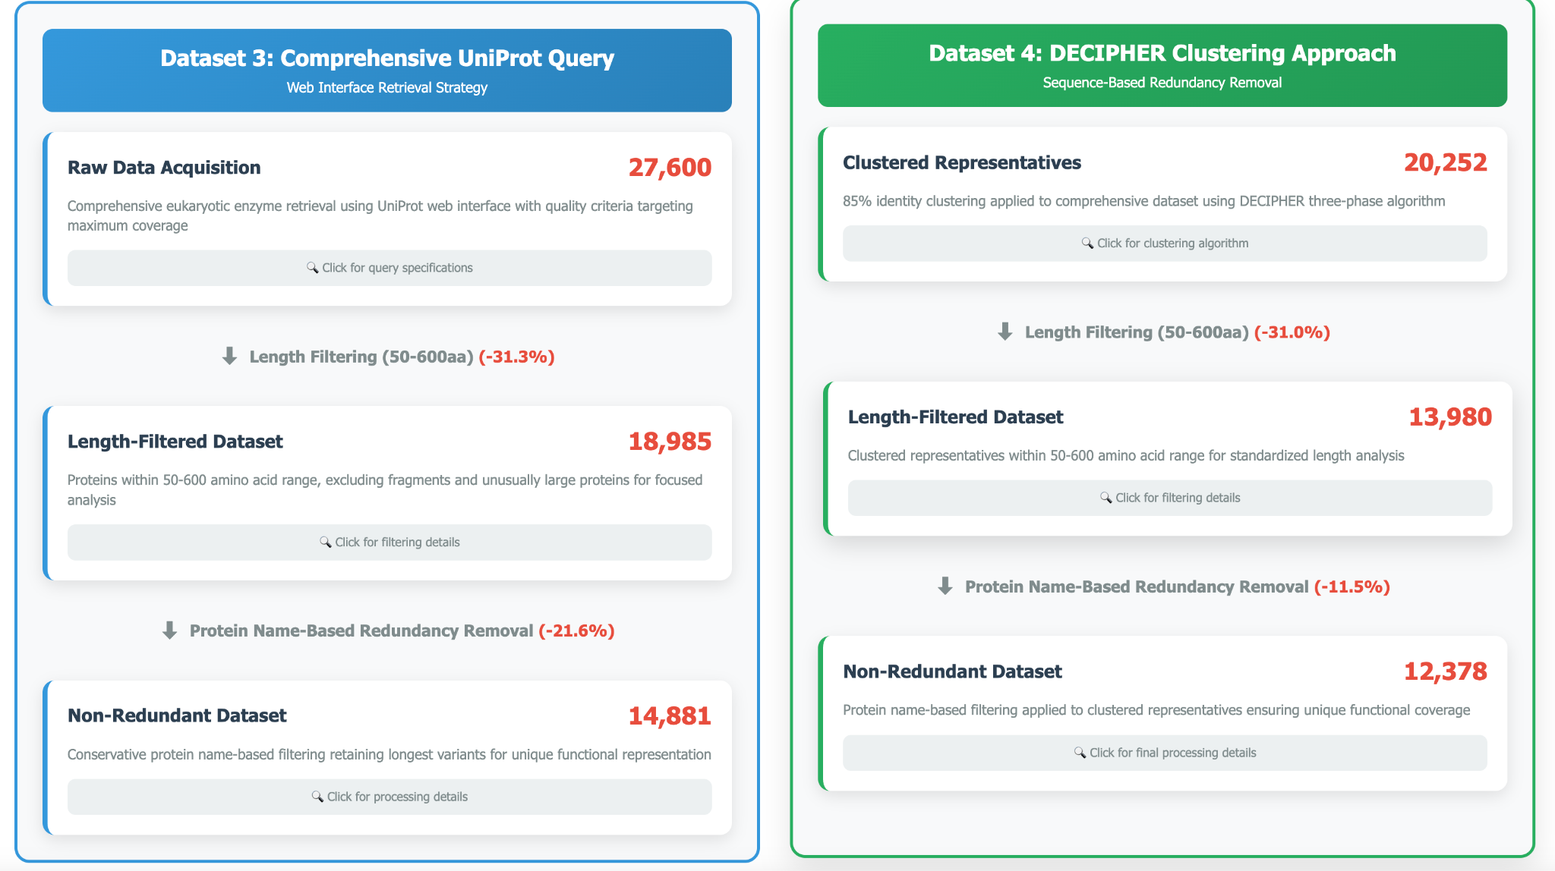

Google Drive Shared Folder For Analysis - Link [HERE]

Supplementary Materials
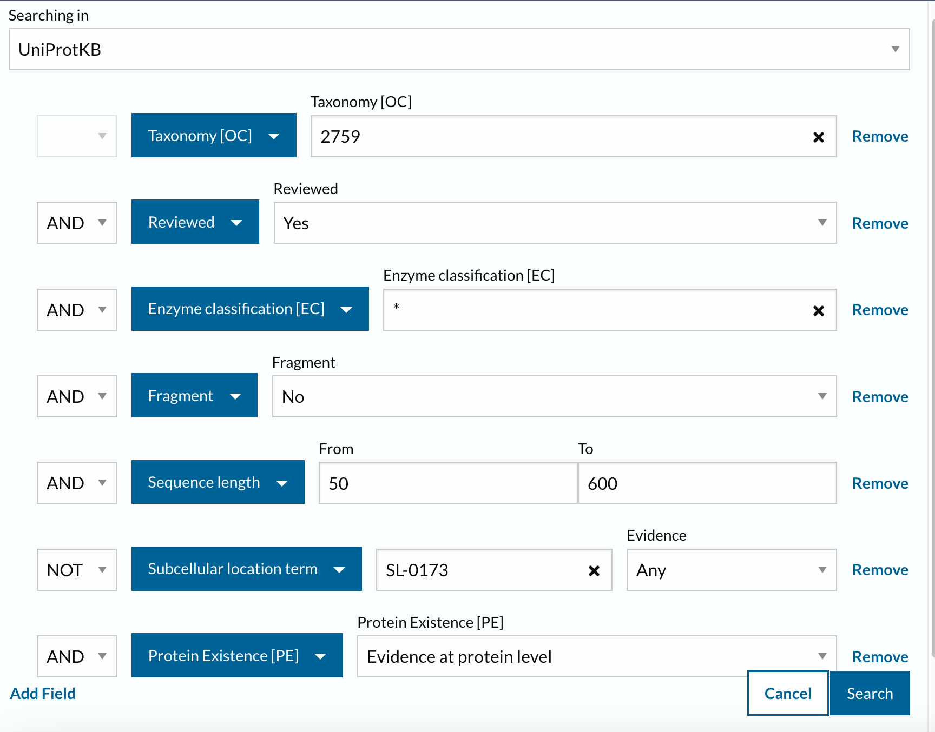

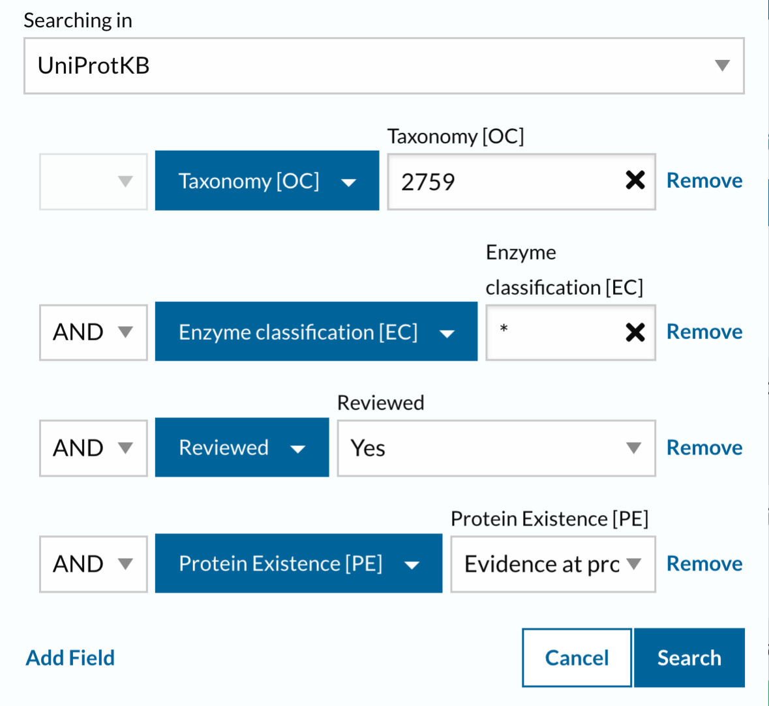

Figure S1. UnitProt APIs. A (Top): used for Datasets 1 and 2, B (Bottom): used for Datasets 3 and 4.

SAD Reproducibility Guide - September 2025
Google Drive Shared Folder For Analysis - Link [HERE]

OPTION A: Full Verification with Preprocessing
For reviewers who want to recreate Dataset 4 from scratch

Part 1: Review Methodology
Step 1: Open 00_OVERVIEW_interactive_methodology.html in browser
Step 2: Review Dataset 3 → Dataset 4 transformation process

Part 2: Run Clusterize Preprocessing
Step 1: Navigate to 01_Clusterize_Preprocessing/
Step 2: Download these files to a local folder:
INPUT_uniprot_27600_proteins.csv (Dataset 3 source originally from Reviewer 3) SCRIPT_clusterize_85percent.R
Step 3: Open RStudio and set working directory to your folder
Step 4: Open and run SCRIPT_clusterize_85percent.R
This will generate multiple output files
The filtered dataset is specifically: filtered_enzyme_dataset.csv
Step 5: Verify output file is created (~20,252 proteins)
This script will generate a file called filtered_enzyme_dataset.csv in your working directory
This file will be renamed to dataset_4.csv for the main analysis
Step 6: Compare with provided OUTPUT_dataset4_20252_proteins.csv
These should be identical (both are the filtered enzyme dataset)

Part 3: Run Main Analysis
Step 7: Navigate to 02_Main_Analysis/
Step 8: Download all datasets and the analysis script
Step 9: Run SCRIPT_SAD_analysis_pipeline.Rmd in RStudio
Step 10: Compare your output with reference HTML
Note: Clusterize output is renamed 'dataset_4' in the Main Analysis pipeline

OPTION B: Quick Start Bundle - Streamlined Version
Google Drive Shared Folder For Analysis - Link [HERE]

Step 1: Navigate to 03_Quick_Start_Bundle/

Step 2: Download Quick_Start_Bundle.zip

Step 3: Extract ZIP to a folder on your computer

Step 4: Open RStudio and set working directory to extracted folder

Step 5: Open SCRIPT_SAD_analysis_pipeline.Rmd

Step 6: Click Knit button (or press Ctrl/Cmd+Shift+K)

Step 7: Wait 10-15 minutes for analysis to complete

Step 8: View your generated HTML output

Why this is recommended:
One download contains everything needed
No complex folder navigation
Pre-organized file structure
Includes simple instructions
Fastest path to verification

OPTION C: Browse Results Only
Google Drive Shared Folder For Analysis - Link [HERE]

For reviewers who just want to see the outputs
No coding required! Simply view:
Step 1: Open 00_OVERVIEW_interactive_methodology.html in your browser
Interactive methodology explorer with clickable elements
Step 2: Open 02_Main_Analysis/REFERENCE_OUTPUT_SAD_results.html
Complete analysis results for all 4 datasets

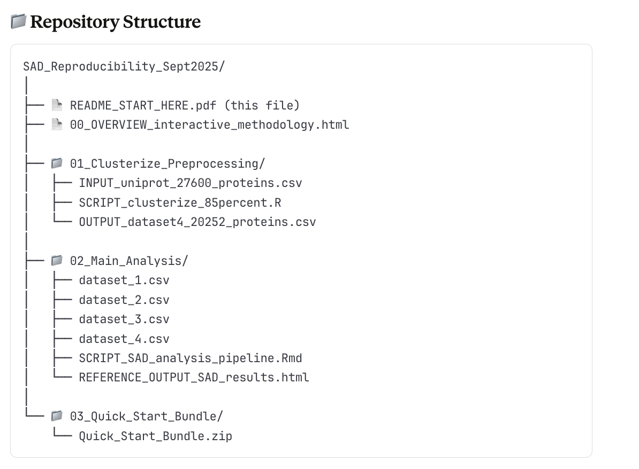

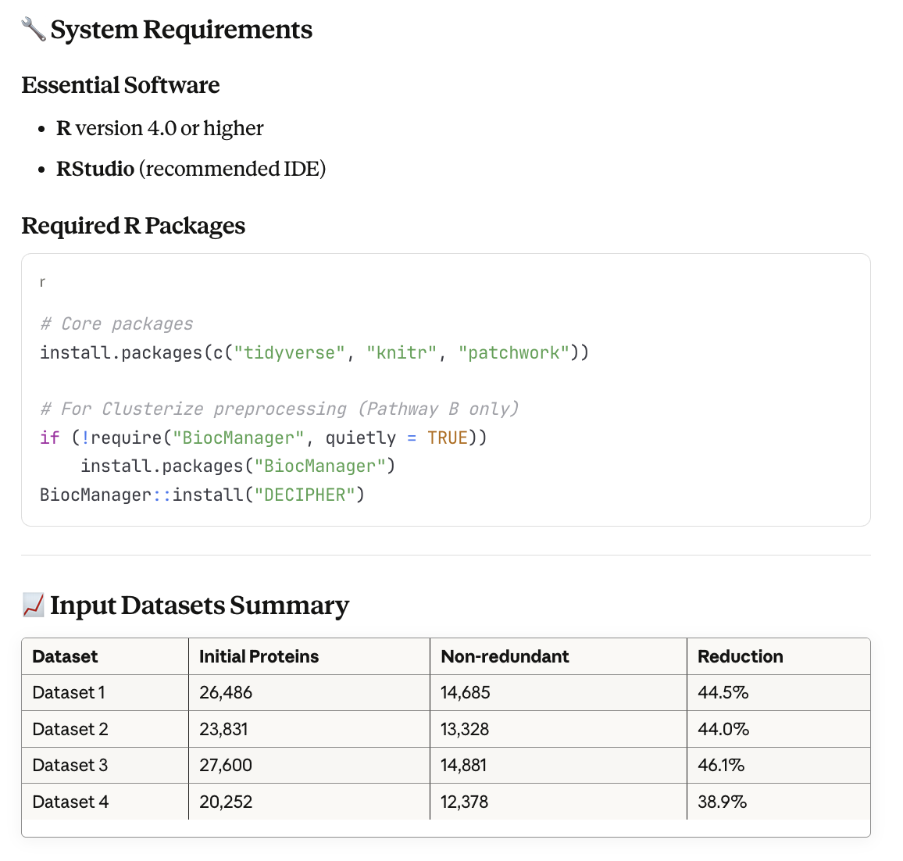
Processing Stages for Each Dataset:
1. Data Standardization: Harmonizing column names across different UniProt data sources
2. Non-redundancy Processing: Protein name-based deduplication (retaining longest variant per Kolker et al. 2002)
3. Length Filtering: Restricting to 50-600 amino acids range
4. SAD Analysis: Spectral Analysis of Distributions using cosine transform (Kolker et al. 2002)
5. Statistical Mixture Modeling (Team C Extension): Maximum likelihood fitting of
gamma background + 4 normal peaks
6. Likelihood Ratio Testing: Statistical significance via χ² test with 6 degrees of freedom
7. Visualization Generation: Length distributions, cosine spectra, and probability density plots

